Essential Questions for Professional Learning
Scope and Sequence for Professional Learning
2015–16

Essential Question for Professional Learning for 2015–16: What coaching moves do Success Coaches/ESD Leads implement to disrupt and dismantle inequitable practices and systems so that ALL students achieve to high levels?

Coaching moves focus on building educator capacity to:
- Strengthen the core instructional program* so that all students access and have support to achieve Washington State Learning Standards.
- Use multiple sources of data to surface and address inequitable outcomes and practices.
- Apply research and evidence-based practices to move effective interventions and educator practices to full implementation, so they reach ALL students who could benefit.
*The Instructional Core is the primary instructional program in which at least 80% of students reach/exceed standards. It's what all students receive as a Tier 1 application of learning.

Strengthening the Core through a Multi-Tiered System of Supports (MTSS)

MTSS provides lens through which we address these three themes for Improvement Initiatives for 2015–16.

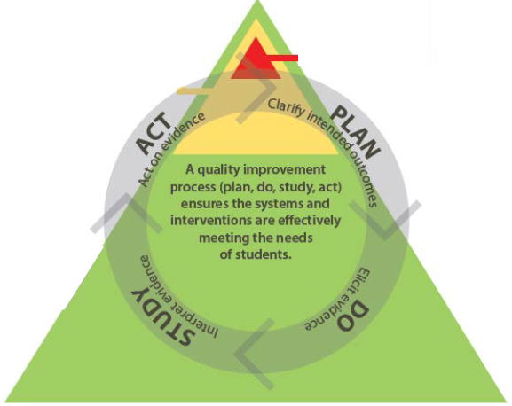

Scope and Sequence for Success Coach Professional Learning for 2015–16
MTSS = Lens for All Professional Learning
 | Topic | Aug  (Kickoff) | Sept - Oct  (Regional Mtg) | Nov (Statewide Mtg) | Jan - Feb  (Regional Mtg) | Mar  (Statewide Mtg) | Apr - May  (Regional Mtg) | June  (Statewide Mtg)
Statewide | Washington State Learning Standards, Assessment of Standards, MTSS = Lens  (Strengthen Core; Use data to surface inequities; Apply research) | - SB Assess: Introduce Data Dashboard  - ELA/Math: SB Interim Assess | - Sept:  - Oct: Strengthening the Core – Intro to Academic Lang Acquisition | All/Breakout  - Culture, Equity, St Discourse (Academic Language Acquisition) | - Jan-Feb RINs: Acad Lang Acq – “Moving beyond academic vocabulary” (theory, review of Ric Pilgrim’s present, applic., IS/LS coaching moves, refl.) | - Acad Lang Acq - Systems and strategies; Sheltered Inst. Models (All)
 | Equity / Systems Data Literacy  (Use data to surface inequities; Strengthen Core; Apply research) | Presentations:  - Data-Driven Dialogues  - PBIS  - ELL Practices  - Co-Teaching  - CEE Data | - Oct: accessing/ using OSPI data reports (if available), | All/Breakout  - Accessing/ using OSPI data reports  - Using ORS  - Interim Assess, using SB data  - Using perceptual data  - Using ELL Data | - Jan-Feb: Access and use actionable data (e.g., data dashboard, ORS, perceptual data)  - Tie to Problem of Practice |  | - Tie to Problem of Practice | Coaches may address as part of the Problem of Practice that informs their T of A and Portfolio.
 | Evidence-based practices in meeting needs of ELLs and SWD  (Strengthen Core; Use data to surface inequities; Apply research) | Presentations:  - MTSS  - PBIS  - ELL Practices  - Co-Teaching  - Instructional Svcs Overview | - Sept:  - Oct; As part of Strengthening the Core – Intro to Acad Lang Acq | Breakout  - Using ELL Data  - Culture, Equity, St Discourse | - Jan-Feb: As part of Strengthening the Core: Acad Lang Acq and strategies for Acad English Learners (ALE) |  |  | Same as above.
 | Other |  |  | - Coach Problems of Practice (Mining the Magic)  - ALE Summit  - LAP Requirements

 | Topic | Aug  (Kickoff) | Sept - Oct  (Regional Mtg) | Nov (Statewide Mtg) | Jan - Feb  (Regional Mtg) | Mar  (Statewide Mtg) | Apr - May  (Regional Mtg) | June  (Statewide Mtg)
RINs | - Portfolio and Theory of Action  - Coach Problems of Practice  - RIN Plan  (Strengthen Core; Use data to surface inequities; Apply research) | Update RIN Plan for 2015-16 | - Sept: Coach Portfolios and T of A  - Sept and Oct: Problems of Practice related to Equity |  | - Jan-Feb: Problems of Practice related to Equity |  |  | Coaches share Portfolios and reflect on new learnings.
 | Regional Plan (RIN Plan)  (Strengthen Core; Use data to surface inequities; Apply research) | Update RIN Plan for 2015-16 | Sept and Oct:  - Use coaches’ Theory of Action and info from Data Analysis  - Submitted 10.30.15(?) | - Review, revise | - Review, revise | - Review , revise |  | Sept and Oct:  Reflection on 2015-16 and goals for 2016=17
 | Indistar®  (Strengthen Core; Use data to surface inequities; Apply research) | Training for New Coaches | Sept:  - Coach Comment Guidance and Peer Review  - Review of Expected Indicators (?)  Oct:  - Support for Plans (due 10.30.15)  - Review plan using SMART Goal Rubric  - Coach Critique Guidance & Review Tool |  | - Coach Critique Review Tool and Rubric (Critique due 3.20.16)  - Coach Comment, Instructional Log Peer Review (optional) |  | - Coach Comment Peer Review  - Coach Critique Review Tool and Rubric (Critique due 6.10.16) | Coaches share evidence on Indistar to support their Portfolio.
OTHER | Success Network evaluation | Completed | - Completed | - Completed

