Why Indistar? Instituting Transformational Teaching and Courageous Leadership

Washington State is a nationally recognized leader in implementing successful turnaround practices. We use the Indistar® Action Planning tool to communicate, streamline, inform, coach, sustain, track and report improvement activities. Seven objective principles align across all School, District, and Regional Improvement Plans: 1) Providing Strong Leadership; 2) Ensuring teachers are effective and able to improve instruction; 3) Redesigning the school day, week, year; 4) Strengthening the school’s instructional program; 5) Using data to inform instruction and continuous improvement, 6) Establishing school environments that improve school safety and discipline; and 7) Providing ongoing mechanisms for family and community engagement. The WA Indistar® template provides 132 “Rapid Turnaround Strategies” within these seven principle areas. Each strategy, or “indicator” is linked to a nationally vetted educational research brief. Identified Focus and Priority school leadership teams are expected to assess a minimum of 17 turnaround indicators out of the 132. District leadership teams have 14 “expected” turnaround indicators; ESD regional teams have 13 to assess. Additionally, an unprecedented 200+ volunteer Indistar® users across Washington employ the tool’s synergy to communicate improvement initiatives between schools, districts, communities and directing boards. In summary, the Indistar® tool is a clearinghouse for aligning effective action strategies and archiving evidences of success.

The Office of Student and School Success Coach supports and guides leadership teams through the “iterative” action planning process. Leadership Coaches design “Theories of Action” with their leadership teams to structure a consensus-building-discourse, analyze and interpret data, assess current levels of development (along a continuum of action), set goals, create tasks to complete goals, monitor, guide, pace, support, encourage and provide critical feedback. Success coaches assure that “well planned intentions” align with transformational practices—system wide.
Continuous Improvement Process

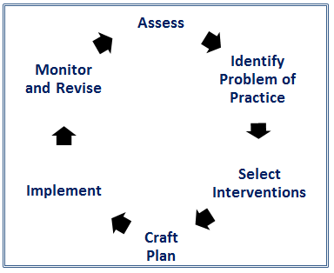
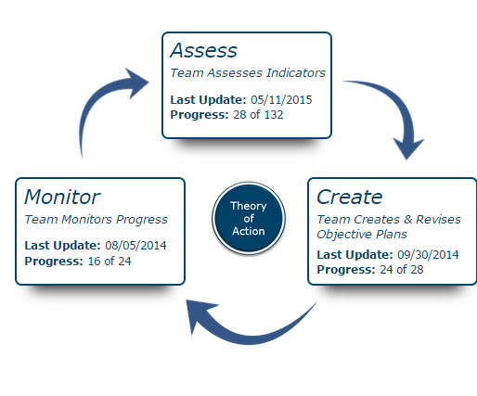
Form Leadership Team
Indistar® Planning Phases

Indistar is premised on the understanding that districts and schools improve and succeed when three things are present and balanced: 1) specific expectations for professional practice; 2) personal investment and engagement to improve the school (i.e. student learning); 3) a climate of candor and trust. Candor means unadorned honesty in examining the professional practice of everyone. Trust is the assurance that the candor is aimed at helping everyone improve in order to achieve the best results for students.
Indistar has simplified and organized the research, translated it into clear statements of effective professional practice (skills), and built a platform where school and district teams can prioritize the skills (what will have the greatest impact immediately), create action steps for making them happen (who will do what and when), and communicate progress around them (here’s what’s working, here’s where we need to do better). It doesn’t do the work of district or school improvement for you, but it makes it easier for you prioritize the work, communicate it, and stay on top of it. Considering the amount of distractions that creep up in a school day (okay, a school hour) that kind of support is critical.
Skills + Indicators of Effective Practice
Indistar is built upon a specific set of practices (or skills routinely exercised) that people must elevate and apply diligently to successfully improve the school. They are called indicators of effective practice (note the indi in Indistar). An indicator of effective practice is a concrete, behavioral expression of a professional practice that contributes to student learning, supported by research. It is expressed in plain language so that a school team can answer easily and with certainty whether it is present or not present. The less gray area the better.
Indistar works because of the people; the teams, who work hard at examining their individual and collective practices— so that students learn more (and learn better). When people in schools focus their time and effort on elevating their specific teaching, leading, connecting, and capacity building— they dedicate actions toward authentic change. They get others involved and excited to do the same.
Teams focus their time (more in some areas than in others) and their effort (a little more here, a lot more there) to perfect their skills and help students perfect theirs. Indistar works because of the people; the teams, who are working hard because they have a new idea—or a problem to solve— and who hold a strong conviction for getting it right.
Indistar works because of the people who use it.

Smart people. Dedicated people. Creative and enthusiastic people.

