October 6, 2015

To: Success Coaches
Fr: Michael Merrin and Craig Shurick
Re: Coach Critique Template and Directions to Submit Critique on Indistar®
The fall Coach Critique serves as the first formal "check" that the school’s Student and School Success Action Plan meets requirements and reflects the use of a variety of data in the action-planning process–from identifying baseline data to setting goals for educator practice and student learning.

The essential question for coaches to consider when writing their Critique is, “Will this plan result in the expected changes in student learning and educator practice?”

Unlike monthly Coaching Comments that reflect the specific ongoing work the Success Coach is doing with the Leadership Team, Coach Critiques provide a broad overview of the school's plan at each of the three submission periods during the school year. School Leadership Teams will use the Coach Critique to inform their thinking as they respond to the Critique and continue to action plan. In addition to providing feedback and information to schools, Coach Critiques also enable leaders in our office to increase our understanding of your work with schools and to inform our practice.

Similar to Coaching Comments, and as appropriate, coaches are encouraged to craft narratives that describe school progress around OSSS “themes for improvement initiatives” for 2015–16: (a) strengthening the core instructional program*; (b) using data to surface and address inequitable outcomes and practices; and (c) applying research to move interventions and evidence-based practices to full implementation so they reach ALL students who can benefit. *The Instructional Core is the primary instructional program in which at least 80% of students reach/exceed standards. It's what all students receive as a Tier I application of learning.

The next pages include the following:
- Template with prompts coaches will use when assessing their school’s plan (p. 3)
- Review Tools that coaches and reviewers use when assessing the Coach Critique (p. 4–5)
- Directions to access and submit the Coach Critique on Indistar® (p. 6)
- Reports and Information on Indistar® to support the narrative for each prompt (p. 7–10)

Coach Critiques are typically 1-2 pages in length. We recommend coaches complete a word-processed version of their Critiques before submitting on Indistar®. In addition to submitting their Coach Critique on Indistar®, coaches may also send an electronic copy of the final Coach Critique to their principal and administrative team. Coaches will submit their Coach Critique for Priority and Focus Schools on Indistar® by Friday, November 20.

Several coaches have inquired about the process our offices uses to review Coach Critiques. Information follows.
- All Coaches: Our office will review Coach Critiques for the October 30, February 28, and May 30 Action Plan submitted by their schools. Reviews are assessed as “Meets Expectations” or “Needs Additional Support.” Coaches receiving a “Needs Additional Support” rating are contacted by our office so we can support them to build their capacity for writing effective Coach Critiques. We will send feedback using Peer Review Tool #2 to each coach (one review/coach) once during the year. Coaches receiving a “Needs Additional Support” rating may have additional reviews to support them to hone their skills in writing narratives.
- New Coaches and Coaches identified as “Needs Additional Support” in 2014–15: We will send feedback using the Peer Review Tool #2 on the Coach Critique for the October 30 plan. Coaches receiving a “Needs Additional Support” rating may have additional reviews to support them as they build their skills in crafting narratives.

The October 21 Regional Improvement Network Agenda includes an opportunity for coaches to collaborate with their peers around accessing, completing, and submitting Coach Critiques on Indistar®.

As always, be sure to ask if questions! MM and CS

Template
Indistar® Action Plan Coach Critique
October 30, 2015 Plan Submission
Due Date for Coach Critiques: Friday, November 20, 2015

The “Coach Critique Review” tools on pages 8–9 of this document provide additional information for writing narratives that respond to the prompts below. Narratives should provide general feedback in the form of affirmations and questions. The essential question guiding your analysis of the plan is, “Will this plan result in the expected changes in student learning and educator practice?”
1. Has a representative Leadership Team (e.g., principal, teachers who lead Instructional Teams, other key professional staff, district representative) been identified? Does the team guide and facilitate the action-planning process?
Coach Response (Insert response in appropriate box in Indistar®)

2. Has the team assessed each of the 17 School-Level Expected Indicators in Indistar®?
Coach Response (Insert response in appropriate box in Indistar®)

3. Is there evidence of one “active” Expected Indicator (with S.M.A.R.T. Goal and appropriate tasks and timelines) under each Turnaround Principle? Note: Coaches use the S.M.A.R.T. Goal Rubric when responding to this prompt; they include affirmations, ask probing questions, and identify next steps based on this rubric.
Coach Response (Insert response in appropriate box in Indistar®)

4. If applicable, assess the school’s response to and evidence provided for the following three questions for “fully implemented” Indicators:
- “How do you know this is happening?”
- “How do you know it is effective?”
- “What needs to be done to sustain this?”
Coach Response (Insert response in appropriate box in Indistar®)

5. How does school explicitly use a variety of data to establish baseline data to assess current level of development and set goals/create the plan? Note: Coaches may consider a variety of proficiency attainment, classroom walkthrough, and other data when responding to this prompt.
Coach Response (Insert response in appropriate box in Indistar®)

Coach Critique Review Tools
Overview: We encourage coaches to engage in a peer review of their Critiques. This enables coaches to hone their skills in crafting narratives and to learn how other coaches are providing feedback.

Review Tool #1: This tool can be used to assess alignment of the narrative with the qualities of effectively written Coach Critique narratives (Column 1). Questions in Column 2 are used by both Coaches and Reviewers when perusing and providing input on the narrative.
Column 1  Attributes of Effectively Written Narratives for Coach Critique Prompts | Column 2  Questions for Coach and Reviewer to Consider
- Prompt #1: Reviews Leadership Team membership and frequency of meetings, and notes specific roles of the team in the action-planning process.  - Prompt #1, 3, and 5: Identifies specific data used by the team as baseline data and to set goals.  - Prompt #2: Reviews plan to ensure all Expected Indicators have been assessed and notes specific indicators that have yet to be addressed.  - Prompt #3: Reviews plan to ensure it includes at least 1 active Expected Indicator for each Turnaround Principle.  - Prompt #3, 5: Reviews goal for each active Indicator to ensure it’s written in S.M.A.R.T. Goal format.  - Prompt #3, 5: References S.M.A.R.T. Goal Rubric when reviewing plan.  - Prompt #3: Notes if tasks appear sufficient to meet the established objective.  - Prompt #3-5: Provides affirmation around plan’s strength and offers probing questions.  - Prompt #3: Offers support to engage the Principal and team in using Indistar® platform to create plans around the school’s initiatives.  - Prompt #3: Identifies if/how plan will result in expected changes in student learning and educator practice.  - Prompt #4: For fully developed Indicators, reviews response to these questions:  - How do you know this is happening?  - How do you know this is effective?  - What needs to be done to sustain this?  - Prompt #1–5: Affirms movement, asks probing questions, and/or identifies next steps for the Principal and team in order to align the school’s action plan with the actual work and initiatives of the school.  - Prompt #1–5: Affirms movement, asks probing questions, and/or identifies next steps with respect to school’s progress with respect to three OSSS “themes for improvement initiatives” for 2015–16. | Questions for the Coach to consider:  - Prompt #1: Is the Leadership Team representative of the school?  - Prompt #1: How does the Leadership Team facilitate and guide the action-planning process?  - Prompt #2, 3, and 5: Does the plan specifically identify data used as baseline data and to set goals?  - Prompt #2: Have all Expected Indicators been assessed in Indistar®?  - Prompt #3: Does plan contain an “active” Expected Indicator under each Student and School Success Principle?  - Prompt #3, 5: Do elements of the S.M.A.R.T. Goals align with the S.M.A.R.T. Goal Rubric?  - Prompt #3: Do tasks identified in the plan appear sufficient to move the goal/objective through the installation stage to initial implementation and eventually to full implementation?  - Prompt #4: Does the Critique address required questions for Indicators assessed as “fully implemented”?  - Prompt #1, 3, and 5: Will this plan result in the expected changes in student learning and educator practice?  Questions for the Reviewer to consider:  - How do comments support the Principal and team to install and implement initiatives and strategies with fidelity?  - In what ways do the comments address alignment of plan with intended goal of building leadership and instructional capacity in order to close gaps and substantially raise student outcomes?  - How do comments support the Principal and team to assess their progress and determine next steps with respect to the three OSSS “themes for improvement initiatives” for 2015–16?

Reviewer Feedback:

Coach Critique Review Tools
Peer Review Tool #2: This tool can be used by coaches as part of a peer review process. It will also be used by the Office of Student and School Success when reviewing Coach Critiques.

 | Attributes of Effectively Written Narratives for Coach Critiques
Prompt | Identifies strengths and areas that must be addressed to satisfy OSPI requirements | Notes if tasks appear sufficient to meet the established objective | Provides affirmation around plan’s strengths and offers probing questions | Identifies if/how plan will result in expected changes in student learning and educator practice | Asks probing questions about and/or identifies next steps for principal and team to align school’s action plan with actual work and initiatives of school | Asks probing questions and/or identifies next steps with respect to three OSSS “themes for improvement initiatives” for  2015–16
Prompt #1  Has a representative Leadership Team been identified? Does the team guide and facilitate the action-planning process? |  | Not applicable for this prompt | Optional | Not applicable for this prompt | Not applicable for this prompt | Not applicable for this prompt
Prompt #2  Has the team assessed each of the 17 School-Level Expected Indicators in Indistar®? |  | Not applicable for this prompt | Optional | Not applicable for this prompt | Not applicable for this prompt | Not applicable for this prompt
Prompt #3  Is there evidence of one “active” Expected Indicator (with S.M.A.R.T. Goal and appropriate tasks and timelines) under each Turnaround Principle? |  |  |  |  |  | Optional
Prompt #4  If applicable, assess the school’s response to and evidence provided for “fully implemented” Indicators. |  | Not applicable for this prompt |  | Not applicable for this prompt |  | Optional
Prompt #5  How does school explicitly use a variety of data to establish baseline data to assess current level of development and set goals/create the plan? |  | Not applicable for this prompt | Optional | Not applicable for this prompt | Optional

Directions to Submit Coach Critiques on Indistar®

Steps to Access and Submit the “Coach Critique”
1. Log in to Indistar® using your School Coach login. Under the “My Schools” tab click the “Show Dashboard” button for the school you wish to access:

2. You are now on the school’s dashboard. Click “Coaching Review”:
3. Click on the “Critique/Feedback” button to access the “Coach Critique” form:

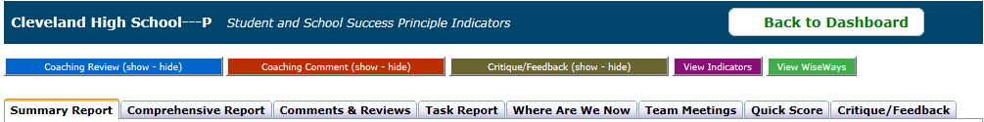

When using the “Coach Critique” form, click “Save” to save your progress. Click “Save and Preview” to save and show a PDF of your work in the form. Click “Save and Submit” when you are ready to submit the feedback to the school. Note: Neither the school nor OSPI is notified when coaches submit the Critique. The report will appear in the “Critique/Feedback” tab (tab on far right above) for the school to access; we suggest coaches notify the principal and administrative team when the Coach Critique has been submitted.

Reports and Information Available on Indistar® for Each Prompt

Reports to Support the Narrative for Each Prompt

Prompt #1: Has a representative Leadership Team (e.g., principal, teachers who lead Instructional Teams, other key professional staff) been identified? Does the team guide and facilitate the action-planning process?
A. School Team Members Report: Identifies Leadership Team members and roles.

Prompt #2: Has the team assessed each of the 17 School-Level Expected Indicators in Indistar®?
A. Summary Report: Displays summary information such as the number of meetings held, numbers of indicators assessed and planned, number of coaching comments, and forms submitted, as well as leadership team information
B. Comprehensive Report: Shows detailed activity of the school team’s work on the improvement plan including assessments, plans, tasks, monitoring, and implementation filtered by 1 month, 3 month, 6 month, 9 month and 12 month time intervals. The status for Indicators brought to full-implementation will state “Objective Met” in bold green.
-Consider use of the Indicator Filter, which can filter out “School Level Expected Indicators” within the plan
-Consider use of the “Show only the Indicators included in the plan” checkbox
-Consider use of the Activity Filter, which can filter out updates made in last month/3months
C. “Where are We Now”: Provides an overview report of the school’s progress on its plan in graph form, as well as a list of fully implemented and completed Indicators.
D. Progress Report: Lists, by Indicator, the target date, as well as the number and status of tasks for each.
Consider sorting by “Task Completed” the Indicator “ID”, or the objective’s “Target Date” by clicking on the arrows in each column header
Prompt #3: Is there evidence of one “active” Expected Indicator (with S.M.A.R.T. Goal and appropriate tasks and timelines) under each Turnaround Principle? Coaches use the S.M.A.R.T. Goal Rubric when responding to this prompt.
A. Progress Report: Lists, by Indicator, the target date, as well as the number and status of tasks for each.
Consider sorting by “Completed” objective, the Indicator “ID”, or the objective’s “Target Date” by clicking on the arrows in each column header
B. Task Report: Lists all tasks, both active and completed, as well as related information.
Consider sorting by “Completed” task, the “Objective” (Indicator) to which they are assigned, or the “Due Date” by clicking on the arrows in each column header

C. Additional information found under “Create” on the dashboard: Lists all Indicators in school’s plan; provides ability to drill down into the assessment, the objective, and associated tasks developed specifically for each Indicator.
-Consider checking the “Hide Completed Plans” box to remove Indicators that have been brought to full implementation
-Consider clicking the “ID” column to sort by Principle
Prompt #4: Assess the school’s response to and evidence provided for the following three questions for “fully implemented” Indicators:
- “How do you know this is happening?”
- “How do you know it is effective?”
- “What needs to be done to sustain this?”
A. Accomplishments Report: Lists only those Indicators that were initially assessed as fully implemented or brought to full implementation within the last year, the last two years, or the last three years.

Prompt #5: How does school explicitly use a variety of data to establish baseline data (assess current level of development), set goals (create plan), and monitor progress? Coaches may consider a variety of proficiency attainment, classroom walkthrough, and other data when responding to this prompt.
- Click on the Assess, Create, and/or Monitor box to drill down into the explicit use of data for each Indicator to review data used by team in Assess, Create, and Monitor stages.
  - Does the team identify data around educator practice and student achievement when assessing an Indicator? These data can serve as baseline data.
  - Does the team set goals around educator practice and student achievement when creating S.M.A.R.T. Goals?
  - For plans with tasks that have been monitored: Does the team use a variety of data to monitor progress?

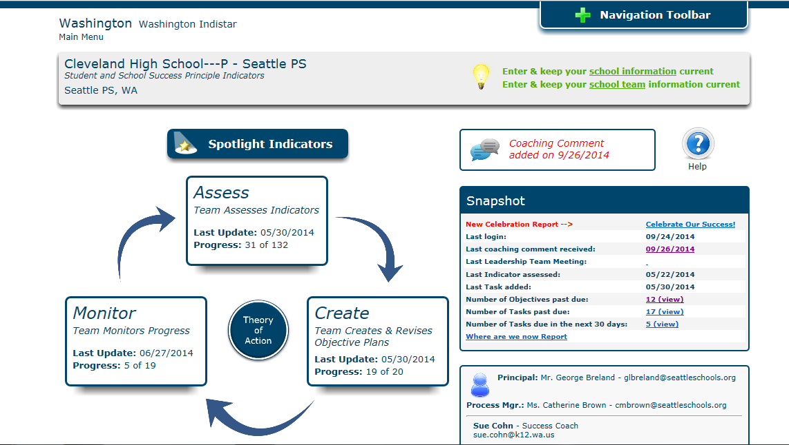

Steps to Access Reports
1. Log in to Indistar® using your School Coach login, or click the “Back to Dashboard” button. Under the “My Schools” tab click the “Show Dashboard” button for the school you wish to access:
2. You are now on the school’s dashboard. Click “Student and School Success Principle Indicators” to access the School’s “Main Page.”
3. Open the “Navigation Toolbar” at the top of the screen.

4. Click “Reports” to access reports.

