January 7, 2016

To: Success Coaches
Fr: Michael Merrin and Craig Shurick
Re: Coach Critique Template and Directions to Submit Critique on Indistar®
Coach Critiques provide a laser-like review of the school’s Student and School Action Plan. They are intended to affirm progress and emphasize highest leverage actions for leadership teams to address. Like the fall Coach Critique, narratives for this Critique should provide feedback in the form of affirmations and questions. The essential questions guiding the coach’s analysis of the plan submitted February 28 include:
- Does this plan reflect the actual work of the school?
- Will it result in the expected changes in student learning and educator practice?

Similar to Coaching Comments, and as appropriate, coaches are encouraged to craft narratives that describe school progress around OSSS “themes for improvement initiatives” for 2015–16: (a) strengthening the core instructional program*; (b) using data to surface and address inequitable outcomes and practices; and (c) applying research to move interventions and evidence-based practices to full implementation so they reach ALL students who can benefit. *The Instructional Core is the primary instructional program in which at least 80% of students reach/exceed standards. It's what all students receive as a Tier I application of learning.

Critiques are typically 1–2 pages in length. We believe a brief, yet thorough, review of the plan will provide the critical information needed by the Principal and Leadership Team. We recommend coaches complete a word-processed version of their Critiques before submitting on Indistar®. In addition to submitting their Coach Critique on Indistar®, coaches may also send an electronic copy of the final Coach Critique to their Principal and administrative team. Coaches submit their Coach Critique for Priority and Focus Schools on Indistar® by March 20, 2016.

The next pages include the following:
- Template with prompts coaches will use when assessing their school’s plan (p. 2)
- Review Tools that coaches and reviewers use when assessing the Coach Critique (p. 3–4)
- Directions to access and submit the Coach Critique on Indistar® (p. 5)
- Reports and Information on Indistar® to support the narrative for each prompt (p. 6–9)
.
The January 20 Regional Improvement Network Agenda includes an opportunity for coaches to collaborate with their peers around accessing, completing, and submitting Coach Critiques on Indistar®.

As always, be sure to ask if questions! MM and CS

Template
Coach Critique for Indistar® Action Plan Submitted February 28, 2016
Due Date for Coach Critiques: Friday, March 20, 2016

Coach Critique narratives should provide general feedback in the form of affirmations and questions. The essential questions guiding the coach’s analysis of the plan include:
- Does this plan reflect the actual work of the school?
- Will it result in the expected changes in student learning and educator practice?

Please cite specific School-Level Expected Indicators, goals, and tasks to support your narratives.

Critique Prompt #1:
Assess the leadership team’s responses to the feedback provided in the Coach Critique for the plan submitted October 30, 2015.
Coach Response (Insert response in appropriate box in Indistar®)

Critique Prompt #2:
Assess the school’s efforts to use a continuous improvement process to plan, implement, monitor, and revise S.M.A.R.T. Goals and tasks aligned with their actual work and initiatives. Assess the team’s progress in uploading evidence in Indistar® that shows progress around their S.M.A.R.T. Goals and tasks.
Coach Response (Insert response in appropriate box in Indistar®)

Critique Prompt #3:
Assess the school’s efforts to ensure all students have access and support to achieve Washington State Learning Standards (Common Core State Standards) and demonstrate proficiency on Smarter Balanced Assessments. Please note specific tasks for Expected Indicators in Principles 2, 4, and/or 5 and/or provide questions to support the team to use the action-planning process to move forward with these initiatives.
Coach Response (Insert response in appropriate box in Indistar®)

Critique Prompt #4 (for Title I Schoolwide schools, Title I Targeted Assistance schools, and Title I schools in Step 1, 2, 3, 4, or 5 of Improvement based on Adequate Yearly Progress [AYP]):
Has the leadership team met the following requirements? If not, please note the items to complete.
- The web form titled “Title I Schoolwide [Targeted Assistance] Checklist of Evidence/Action” has been completed and submitted.
- The evidence for each of the required Title I Schoolwide or Title I Targeted Assistance components has been uploaded into the appropriate folders within Indistar®.
- The web form titled “ESEA-AYP School Improvement Plan Checklist” has been completed and submitted in Indistar® for schools in Step 1, 2, 3, 4, or 5 of Improvement based on Adequate Yearly Progress.
Coach Response (Insert response in appropriate box in Indistar®)

Coach Critique Review Tools – Review Tool #1
Overview: We encourage coaches to engage in a peer review of their Critiques. This enables coaches to hone their skills in crafting narratives and to learn how other coaches are providing feedback. This tool can be used to assess alignment of the narrative with the qualities of effectively written Coach Critique narratives (Column 1). Questions in Column 2 are used by both Coaches and Reviewers when perusing and providing input on the narrative.
Column 1  Attributes of Effectively Written Narratives for Coach Critique Prompts | Column 2  Questions for Coach and Reviewer to Consider (Cite Specifics from Plan When Possible)
- Prompt #1: Reviews how school responded to Coach Critique for October 30 Plan; identifies next steps if needed.  - Prompt #2: Assesses school’s efforts to use Indistar® as platform for continuous improvement process to plan, implement, monitor, and revise S.M.A.R.T Goals/tasks.  - Prompt #2: Reviews school’s efforts to align plan on Indistar® with “real”/actual work of school.  - Prompt #2: Assesses team’s efforts to upload evidence to Indistar® showing progress.  - Prompt #2: Offers support to engage the Principal and team in using Indistar® platform to create plans around the school’s initiatives.  - Prompt #3: Identifies if/how plan includes goals/tasks ensuring all students have access and support to achieve WA State Learning Standards (cite specifics from Principles 2, 4, and 5).  - Prompt #3: Identifies if/how plan includes goals/tasks ensuring all students have access and support to demonstrate proficiency on Smarter Balanced Assessments (cite specifics from Principles 2, 4, and 5).  - Prompt #1–3: Identifies specific data used by team to set goals and monitor progress.  - Prompt #1–3: Reviews S.M.A.R.T. Goals to determine alignment with S.M.A.R.T. Goal Rubric.  - Prompt #2 and 3: Notes if tasks appear sufficient to meet the established objectives.  - Prompt #2 and 3: Identifies if/how plan will result in expected changes in student learning and educator practice.  - Prompt #1–3: Affirms movement, asks probing questions, and/or identifies next steps with respect to school’s progress with respect to three OSSS “themes for improvement initiatives” for 2015–16.  - Prompt #4 (if required): Notes if the school completed all requirements for Schoolwide/Targeted Assistance Plans and/or plans for schools in step of improvement; identifies next steps as appropriate. | Questions for the Coach to consider:  - Prompt #1: How did Leadership Team respond to Coach Critique for October 30 Plan?  - Prompt #2: How does the narrative support the Principal and team to use Indistar® for action-planning and to monitor/revise plans as they move forward?  - Prompt #2: How does the plan reflect the “real”/actual work and initiatives of the school this year?  - Prompt #3: What tasks in the plan address goal of ensuring all students have access and support to achieve WA State Learning Standards?  - Prompt #3: What tasks in the plan address goal of ensuring all students have access and support to demonstrate proficiency on Smarter Balanced Assessments?  - Prompt #1–3: Do elements of S.M.A.R.T. Goals align with S.M.A.R.T. Goal Rubric?  - Prompt #1–3: How does the coach use affirmations and probing questions to move improvement efforts forward?  - Prompt #1–3: Will this plan result in the expected changes in student learning and educator practice?  - Prompt #4 (if required): Does the plan satisfy requirements for Title I Schoolwide/Targeted Assistance Plans and plans for schools in step of improvement?  Questions for the Reviewer to consider:  - How do comments support the Principal and team to install and implement initiatives and strategies with fidelity?  - In what ways do the comments address alignment of plan with intended goal of building leadership and instructional capacity in order to close gaps and substantially raise student outcomes?  - How do comments support the Principal and team to assess their progress and determine next steps with respect to the three OSSS “themes for improvement initiatives” for 2015–16?

Reviewer Feedback:

Coach Critique Review Tools – Review Tool #2
Overview: This tool can be used by coaches as part of a peer review process. It will also be used by the Office of Student and School Success when reviewing Coach Critiques.
 | Attributes of Effectively Written Narratives for Coaching Critiques
Prompt | Identifies strengths and areas that must be addressed to satisfy OSPI requirements | Notes if tasks appear sufficient to meet the established objective | Provides affirmations or offers probing questions around plan’s strengths | Identifies if/how plan will result in expected changes in student learning and educator practice | Asks probing questions about and/or identifies next steps for Principal and team to align school’s action plan with actual work and initiatives of school | If applicable, notes if team satisfied requirements to submit web form(s) and upload required evidence; asks probing questions and/or offers suggestions to satisfy requirements*
Prompt #1  Did the team respond to feedback in October Coach Critique? Did the team edit/revise plan in response to October Coach Critique? |  | Optional | Optional | Optional | Optional | Not applicable for this prompt
Prompt #2  Is the school implementing a continuous improvement process? Do S.M.A.R.T. Goals align with the actual work of the school? Is the school using Indistar to upload evidence of implementation and impact? | Not applicable for this prompt |  |  |  |  | Not applicable for this prompt
Prompt #3  Is there evidence of school’s efforts to (a) implement WA State Standards in ELA and Math for all students and (b) prepare all students to demonstrate proficiency on Smarter Balanced Assessments? | Not applicable for this prompt |  |  |  |  | Not applicable for this prompt
Prompt #4 (if required)*  Did the team submit the required web form(s) and upload required evidence? | Not applicable for this prompt | Not applicable for this prompt | Not applicable for this prompt | Not applicable for this prompt | Not applicable for this prompt
Reviewer Feedback:

Directions to Submit Coach Critiques on Indistar®

Steps to Access and Submit the “Coach Critique”
1. Log in to Indistar® using your School Coach login. Under the “My Schools” tab click the “Show Dashboard” button for the school you wish to access:

2. You are now on the school’s dashboard. Click “Coaching Review”:
3. Click on the “Critique/Feedback” button to access the “Coach Critique” form:

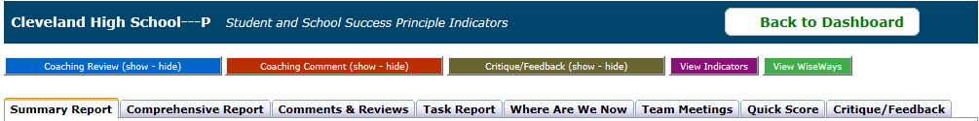

When using the “Coach Critique” form, click “Save” to save your progress. Click “Save and Preview” to save and show a PDF of your work in the form. Click “Save and Submit” when you are ready to submit the feedback to the school. Note: Neither OSPI nor the coach is notified when the Critique is submitted on Indistar. However, the principal and process manager receive an auto-generated email stating the Critique is available for review. The Critique/report will appear in the “Critique/Feedback” tab (tab on far right above) for the school to access. We suggest coaches notify the Principal and administrative team when the Coach Critique has been submitted.

Reports and Information Available on Indistar® for Each Prompt

Reports and Evidence to Support the Narrative for Each Prompt

Prompt #1: Assess the leadership team’s responses to the feedback provided in the Coach Critique for the plan submitted October 30, 2015.
- Comprehensive Report: Shows detailed activity of the school team’s work on the improvement plan including assessments, plans, tasks, monitoring, and implementation filtered by 1 month, 3 month, 6 month, 9 month and 12 month time intervals. The status for Indicators brought to full-implementation will state “Objective Met” in bold green.
-Consider use of the Indicator Filter, which can filter out “School Level Expected Indicators” within the plan
-Consider use of the “Show only the Indicators included in the plan” checkbox
-Consider use of the Activity Filter, which can filter out updates made in last month/3months.

Prompt #2: Assess the school’s efforts to use a continuous improvement process to plan, implement, monitor, and revise S.M.A.R.T. Goals and tasks aligned with their actual work and initiatives. Assess the team’s progress in uploading evidence in Indistar® that shows progress around their S.M.A.R.T. Goals and tasks.
- Comprehensive Report: Shows detailed activity of the school team’s work on the improvement plan including assessments, plans, tasks, monitoring, and implementation filtered by 1 month, 3 month, 6 month, 9 month and 12 month time intervals. The status for Indicators brought to full-implementation will state “Objective Met” in bold green.
-Consider use of the Indicator Filter, which can filter out “School Level Expected Indicators” within the plan
-Consider use of the “Show only the Indicators included in the plan” checkbox
-Consider use of the Activity Filter, which can filter out updates made in last month/3months
- Progress Report: Lists, by Indicator, the target date, as well as the number and status of tasks for each.
Consider sorting by “Task Completed” the Indicator “ID”, or the objective’s “Target Date” by clicking on the arrows in each column header.
- Additional information found under “Create” on the dashboard: Lists all Indicators in school’s plan; provides ability to drill down into the assessment, the objective, and associated tasks developed specifically for each Indicator.
-Consider checking the “Hide Completed Plans” box to remove Indicators that have been brought to full implementation.
-Consider clicking the “ID” column to sort by Principle.

Prompt #3: Assess the school’s efforts to ensure all students have access and support to achieve Washington State Learning Standards (Common Core State Standards) and demonstrate proficiency on Smarter Balanced Assessments. Please note specific tasks for Expected Indicators in Principles 2, 4, and/or 5 and/or provide questions to support the team to use the action-planning process to move forward with these initiatives.
- Progress Report: Lists, by Indicator, the target date, as well as the number and status of tasks for each. Consider sorting by “Completed” objective, the Indicator “ID”, or the objective’s “Target Date” by clicking on the arrows in each column header.
- Task Report: Lists all tasks, both active and completed, as well as related information.
Consider sorting by “Completed” task, the “Objective” (Indicator) to which they are assigned, or the “Due Date” by clicking on the arrows in each column header.
- Additional information found under “Create” on the dashboard: Lists all Indicators in school’s plan; provides ability to drill down into the assessment, the objective, and associated tasks developed specifically for each Indicator.
-Consider checking the “Hide Completed Plans” box to remove Indicators that have been brought to full implementation
-Consider clicking the “ID” column to sort by Principle.

Prompt #4: Has the leadership team met the following requirements? If not, please note the items to complete.
- The web form titled “Title I Schoolwide [Targeted Assistance] Checklist of Evidence/Action” has been completed and submitted.
- The evidence for each of the required Title I Schoolwide or Title I Targeted Assistance components has been uploaded into the appropriate folders within Indistar®.
- The web form titled “ESEA-AYP School Improvement Plan Checklist” has been completed and submitted in Indistar® for schools in Step 1, 2, 3, 4, or 5 of Improvement based on Adequate Yearly Progress.
- Document Upload: Includes evidence uploaded by team to show evidence of implementation and impact.
- Submit Forms/Reports Tab: includes completed webforms for Schoolwide, Targeted Assistance, and School Improvement Plans.

Steps to Access Reports
1. Log in to Indistar® using your School Coach login, or click the “Back to Dashboard” button. Under the “My Schools” tab click the “Show Dashboard” button for the school you wish to access:
2. You are now on the school’s dashboard. Click “Student and School Success Principle Indicators” to access the School’s “Main Page.”
3. Open the “Navigation Toolbar” at the top of the screen.

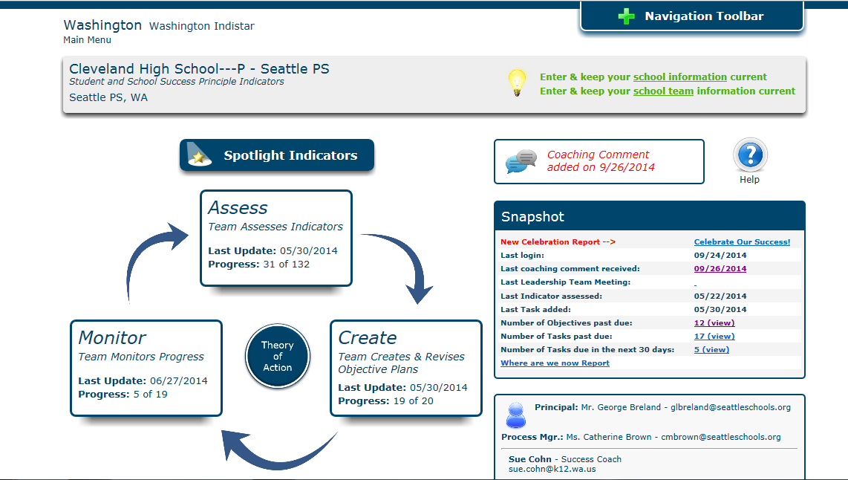

4. Click “Reports” to access reports.

